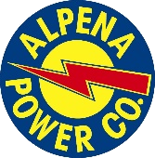
ALPENA POWER COMPANY
401 N. Ninth Ave Alpena, Michigan 49707

For Immediate Release February 22, 2024

Contact: Matt Cameron
Vice President
989-358-4948

On the weekend beginning Saturday, February 24th Alpena Power Company customers in the Village of Hillman will experience two brief power outages. International Transmission Company (ITC) will be performing maintenance on the power line feeding the Village of Hillman. In order to maintain service to its customers during this time, Alpena Power will transfer the Hillman Village load to its substation located on King Settlement Rd. To accomplish this, customers will experience a short outage at approximately 2:15 a.m. Saturday morning the 24th of February. ITC anticipates completing their maintenance by Sunday night the 25th of February. Alpena Power customers will then experience a second brief outage at 2:00 a.m. Monday, February 26th when the system is put back to normal and load is transferred back to the Hillman substation.

